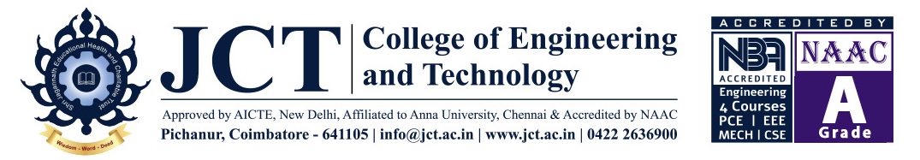

DEPARTMENT OF CIVIL ENGINEERING
Date: 14.12.2022
Name of the Event : International webinar
Meeting Link : https://meet.google.com/vxb-ptxp-pmh
Date & Time : 21.12.2022 To 24.12.2022 & 07.00 PM

To:
The Principal,
JCTCET,
Pichanur, Coimbatore – 105

Respected Sir,
Sub: Requisition to conduct International webinar – reg.

We are planned to conduct virtual International webinar on “International Opportunities for Civil Engineers” for Civil Engineering Students. So I request you to give permission to conduct the above event.
Thanking you.

Yours faithfully,

HoD/Civil

Date : 14.12.2022
Station: JCTCET, CBE

DEPARTMENT OF CIVIL ENGINEERING
International Webinar Series
Date : 21.12.2022 to 24.12.2022
Time : 07.00 PM Onwards
Virtual Platform : Google Meet
Agenda of the Program
S.No | Date | Chief Gust | Topics | Time | Meet Link
1 | 21.12.2022 | Er.Adithya Hariharan M S  Deputy Manager,  COOEC - Flour Heavy Industries,  USA | Modular Steel Construction | 7.00 PM  to  8.30 PM | https://meet.google.com/vxb-ptxp-pmh
2 | 22.12.2022 | Mr.Surya Ravichandran  Research Scholar  University of East London | Opportunities for Higher Education In UK
3 | 23.12.2022 | Er. Gokul R K  Quantity Surveyor  EMCO, Quatar | Professional Opportunities & Certification
4 | 24.12.2022 | Er.Sreepathy  Project Manager,  Parsons International Ltd,  Abu Dhabi | Impact of Infrastructures in Middle East

